**Project Report On**

**Book a Doctor - DocSpot**

A MERN Stack Appointment Booking System

**SUBMITTED BY**

Team ID: LTVIP2025TMID56525

Team Size: 4

**Team Leader**: Krishnaveni Mamidisetti

Team member: Jaddu Bhargavi

Team member: Kommina Manusha

Team member: Vignesh Talabattula

**SUBMITTED TO :**

 



**1. INTRODUCTION**

**1.1 Project Overview**

DocSpot is a full-stack web application developed using the MERN (MongoDB, Express.js,

React.js, Node.js) stack. It is designed to modernize and simplify the process of scheduling

medical appointments. The platform rm serves as a centralized hub connecting patients,

doctors, and administrators, providing each with a tailored interface to manage the

appointment lifecycle efficiently. By eliminating traditional booking hassles like phone calls

and long wait times, DocSpot offer a convenient, user-friendly, and real-time solution for

healthcare management. The system is built on a robust client-server architecture, features

role-based access control for security, and provides a seamless user experience from

registration to post-appointment follow-up.

**1.2 Purpose**

The primary purpose of the Doc Spot project is to address the inefficiencies of traditional

appointment booking systems. The goal is to create a seamless digital experience that

benefit s all stakeholders.

|  |  |
| --- | --- |
| • | **For Patei nts:** To provide 24/7 access to browse doctors, view real-time availability, |

and book appointments from the comfort of their homes, reducing wait times and

uncertainty.

|  |  |
| --- | --- |
| • | **For Doctors:** To ofef r a powerful dashboard to manage their schedules, view patient |

information, and control their appointment confirmations, thereby reducing the

administrative load on their staff

|  |  |
| --- | --- |
| • | **For the Platoform:** To create a scalable, secure, and reliable system that can be trusted |

by both patients and healthcare professionals.

**2. IDEATION PHASE**

**2.1 Problem Statement**

Booking a doctor's appointment is an outdated and ofet n frustrating process for patients. It

typically involves making phone calls during limited ofcfi e hours, being placed on hold,

playing phone tag with receptionists and having no clear visibility into a doctor's availability.

This leads to wasted time, delayed healthcare, and a poor patient experience. For doctors'

offices, this manual process consumes significant administrative resources that could be

beet r spent on patient care.

**2.2 Empathy Map Canvas (for a typical patient)**

|  |  |
| --- | --- |
| • | **THINKS & FEELS:** "I hope I can get an appointment this week." "This is so frustrating, |

I've been on hold for 10 minutes." "I wish I knew which doctors accepted my

insurance." "I feel anxious about my health, and this process is just adding more

stress."



|  |  |
| --- | --- |
| • | **SEES:** Busy receptionists, limited time slots, confusing clinic websites, long waiting |

lists.

|  |  |
| --- | --- |
| • | **SAYS & DOES:** "Do you have any availability for next Tuesday morning?" "I'll have to |

call back later." Spends time searching online for doctor reviews. Asks friends for

recommendations.

|  |  |
| --- | --- |
| • | **HEARS:** "The doctor is fully booked for the next two weeks." "Please hold, I'll check |

the schedule." "You'll need to call back on Monday to book."

|  |  |
| --- | --- |
| • | **PAINS:** Wasted time, frustration, uncertainty, inability to book outside of 9-5 hours, |

delayed access to care.

|  |  |
| --- | --- |
| • | **GAINS:** Convenience, control over their schedule, quick confirmation, peace of mind, |

ability to book anytime, anywhere.

**2.3 Brainstorming**

Initial brainstorming sessions produced several potential solutions, including a dedicated

mobile application, an automated phone-based IVR system, and a comprehensive web

Platform. The web platform was chosen as the initial product due to its universal

accessibility across devices (desktops, tablets, phones) without requiring a download, and

for allowing a faster development cycle. Key features brainstormed included:

|  |  |
| --- | --- |
| •  •  •  •  •  • | User profiles for patients and doctors.  Real-time calendar availability.  Search and filter functionality (by specialty, location).  Automated email/SMS notifications.  An admin panel for quality control and verification.  Secure document handling for medical information. |

**3. REQUIREMENT ANALYSIS**

**3.1 Customer Journey Map (Patei nt)**

1. **Registration /Login:** The user visits the site and creates a new patient account or logs

into an existing one.

2. **Discovery:** The user lands on a dashboard where they can search for doctors. They

apply filters such as specialty and location.

3. **Selection n:** The user reviews the profiles of matching doctors and selects one based

on their credentials and availability.

4. **Booking:** The user clicks "Book Now," selects a desired date and time from the

doctor's real-time calendar, and submits the appointment request.

5. **Confirmation n:** The user receives an initial notification that their request has been

sent. Once the doctor approves it, the user receives a final confirmation notification.

6. **Management:** The user can view their upcoming appointments in their dashboard

and has the option to cancel or reschedule.

7. **Appointment Day:** The user attends the appointment.

8. **Follow-up:** The user receives a visit summary or follow-up instructions via the app.

**3.2 Solution n Requirement**

|  |  |
| --- | --- |
| • | **Functional Requirements:** |

o User registration and authentication for all three roles (Patient, Doctor,

Admin).

o Secure login with password hashing (crypt) and session management (JWT).

o Role-based dashboards with different functionalities for each user type.

o Admin functionality to view and approve/reject new doctor applications.

o Doctor functionality to manage their profile, set availability, and

confirm/cancel appointments.

o Patient functionality to search for doctors, book appointments, and view

appointment history.

o A notification system for appointment status changes.

|  |  |
| --- | --- |
| • | **Non-Functional Requirements:** |

o **Security:** All sensitive data must be encrypted, and access to routes must be

protected based on user roles.

o **Performance:** The application must have fast load times and quick API

responses.

o **Usability:** The user interface must be intuitive, clean, and easy to navigate for

non-technical users.

o **Scalability:** The architecture should be able to handle a growing number of

users and appointments.

**3.3 Data Flow Diagram (DFD)**

A typical data flow for booking an appointment is as follows:

1. **User (Patient)** provides booking details (date, time) via the **React Frontend**.

2. The Frontend, using **Axios**, sends a POST request with the booking data and the

user's JWT authentication token to the **Express Backend API** (e.g.,

/api/appointments/book-appointment).



3. The **Express Router** directs the request to the appropriate **Controller** function.

4. The Controller validates the input and uses the **Mongoose Model** to create a new

appointment document.

5. **Mongoose** translates this into a command that saves the document in the **MongoDB**

**Database**.

6. The database confirms the save, and the Controller sends a success response (e.g.,

201 Created) back to the Frontend.

7. The React Frontend receives the success response and displays a confirmation

message to the user.

**3.4 Technology Stack**

|  |  |
| --- | --- |
| •  •  •  •  •  • | **Frontend:** React.js, React Router, Axios, Ant Design (for UI components)  **Backend:** Node.js, Express.js  **Database:** MongoDB  **ODM (Object Data Modeling):** Mongoose  **Authentication:** JSON Web Tokens (JWT), bcrypt.js  **Development Tools:** VS Code, Git, npm |

**4. PROJECT DESIGN**

**4.1 Problem Solution Fit**

The DocSpot platform directly addresses the core problems identified d.

|  |  |
| --- | --- |
| • | **Problem:** Limited booking hours and phone tag. |

o **Solution:** A 24/7 web platform that allows instant booking requests.

|  |  |
| --- | --- |
| • | **Problem:** Lack of transparency in doctor availability. |

o **Solution:** A real-time calendar system that shows doctors' actual open slots.

|  |  |
| --- | --- |
| • | **Problem:** High administrative burden on clinics. |

o **Solution:** A self-service platform for patients and a simple management

dashboard for doctors, automating the booking process.

**4.2 Proposed Solution**

The proposed solution is a three-tiered MERN stack application. It consists of a client-side

React application that communicates with a server-side Express API, which in turn interacts

with a MongoDB database. The system is divided into three core user modules:



1. **Patei nt Module:** Allows users to register, log in, search for doctors, and manage their

appointments.

2. **Doctor Module:** Allows approved doctors to manage their professional profile, set

their schedule, and approve or decline incoming appointment requests.

3. **Admin Module:** A backend interface for administrators to verify and approve new

doctor registrations, ensuring the quality and legitimacy of providers on the platform.

**4.3 Solution Architecture**

The application follows a classic three-tier architecture:

1. **Presentation Layer (Frontend):** A React-based Single Page Application (SPA) that

renders the UI in the user's browser. It manages the view layer and user interactions

2. **Logic Layer (Backend):** A Node.js/Express.js server that exposes a RESTful API. It

handles all business logic, authentication, authorization, and acts as the intermediary

between the frontend and the database.

3. **Data Layer (Database):** A MongoDB database managed by Mongoose schemas. It is

responsible for the persistent storage of all application data, including user profiles,

doctor details, and appointment records.

**5. PROJECT PLANNING & SCHEDULING**

**5.1 Project Planning**

The project was executed in four distinct phases:

|  |  |
| --- | --- |
| • | **Phase 1: Foundation & Backend (Week 1):** |

o Environment setup and project structure initialization.

o Design of Mongoose schemas for Users and Appointments.

o Development of the backend API for user registration and login, including

JWT authentication.

|  |  |
| --- | --- |
| • | **Phase 2: Core Frontend & Patei nt Features (Weeks 2-3):** |

o Setup of the React frontend with routing.

o Development of UI pages for Login, Registration, and the main dashboard

using Ant Design.

o Integration of registration/login forms with the backend API.

o Implementation of doctor listing and search functionality.

|  |  |
| --- | --- |
| • | **Phase 3: Doctor & Admin Modules (Week 4):** |

o Development of the "Apply as Doctor" feature.

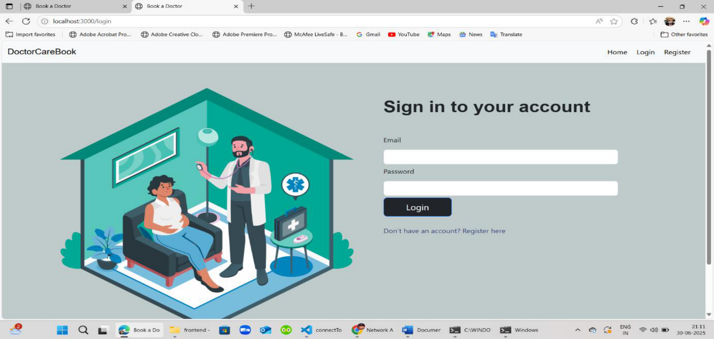

o Creation of the Admin dashboard for viewing and approving doctors.

o Creation of the Doctor dashboard for managing appointments.

|  |  |
| --- | --- |
| • | **Phase 4: Testing & Refinement (Week 5):** |

o End-to-end functional testing of all user journeys.

o UI/UX refni ement and bug fxi ing.

o Preparation of the fni al report and project demonstration.

**6. FUNCTIONAL AND PERFORMANCE TESTING**

**6.1 Performance Testing**

While extensive automated testing was outside the project's immediate scope, the following

testing strategies were considered and manually performed:

|  |  |
| --- | --- |
| • | **Functional Testing:** Manually tested all core user flows, including patient registration, |

doctor application, admin approval, and the complete appointment booking cycle to

ensure they function as expected.

|  |  |
| --- | --- |
| • | **API Endpoint Testing:** Used the frontend application to test API responses for |

correctness, including success and error states for all endpoints.

|  |  |
| --- | --- |
| • | **Usability Testing:** Ensured the UI is intuitive and responsive across different screen |

sizes (desktops and mobile browsers).

|  |  |
| --- | --- |
| • | **Security Testing:** Verified that protected routes are inaccessible without a valid JWT |

token and that one user cannot access another user's data.

**7. RESULTS**

**7.1 Output Screenshots**

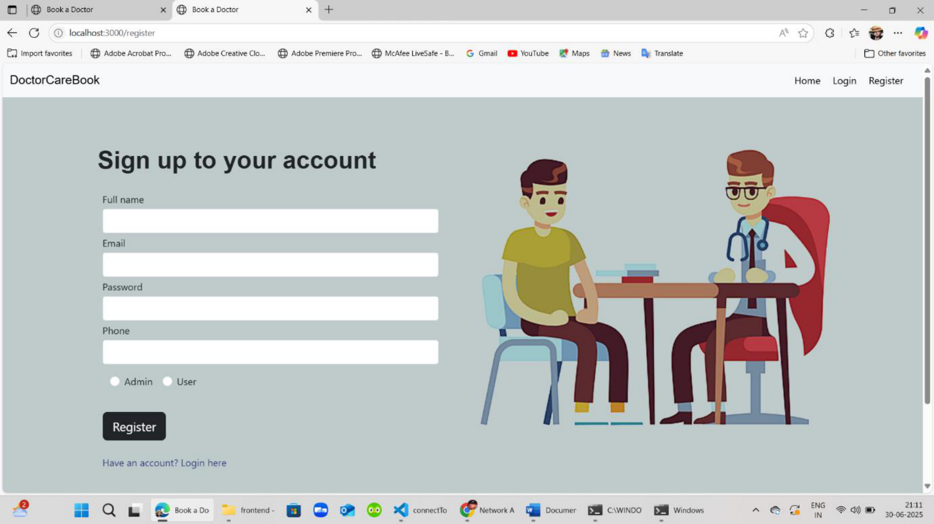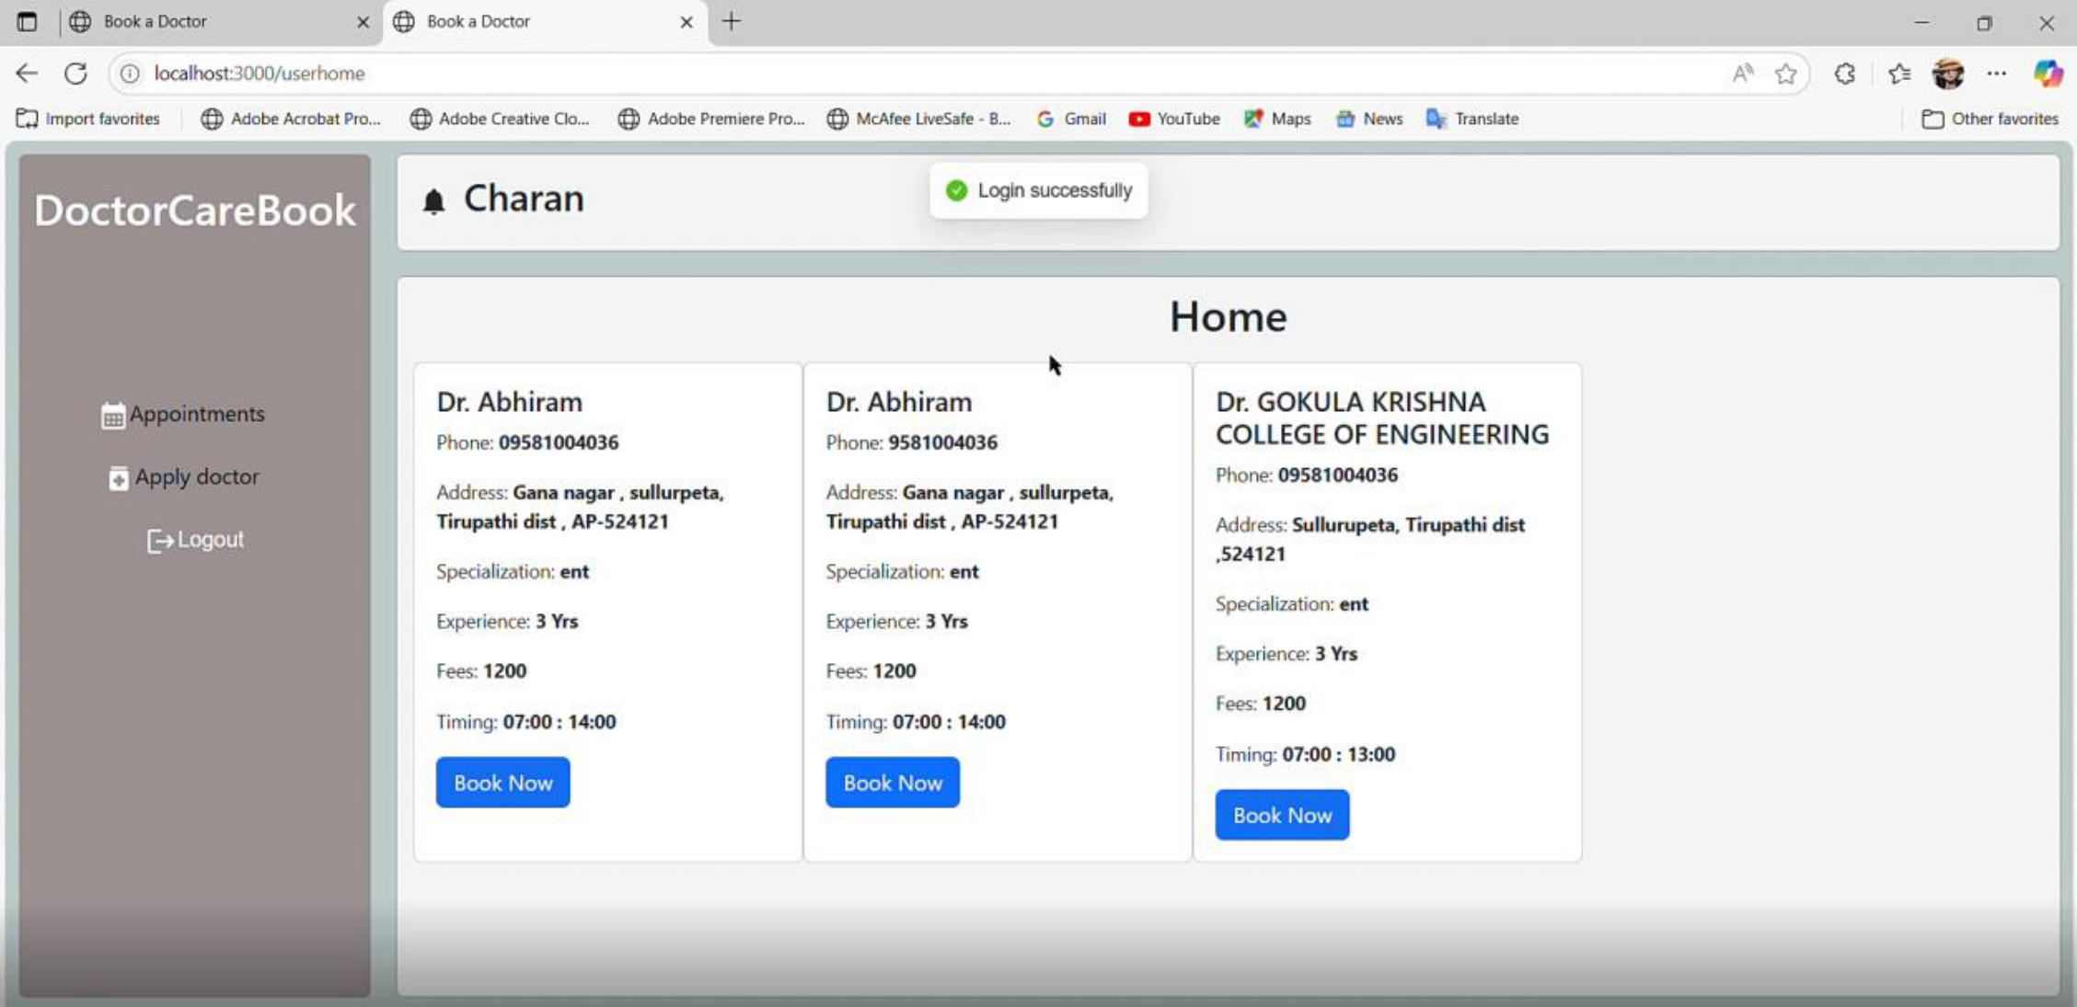

**Captoi n 1: User Registratoi n Page**

**Captoin 2: Doctor Listing and Search Page**

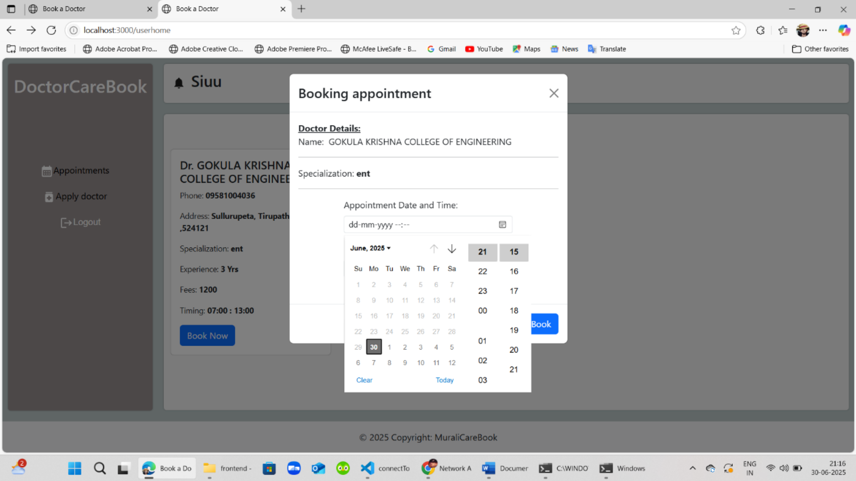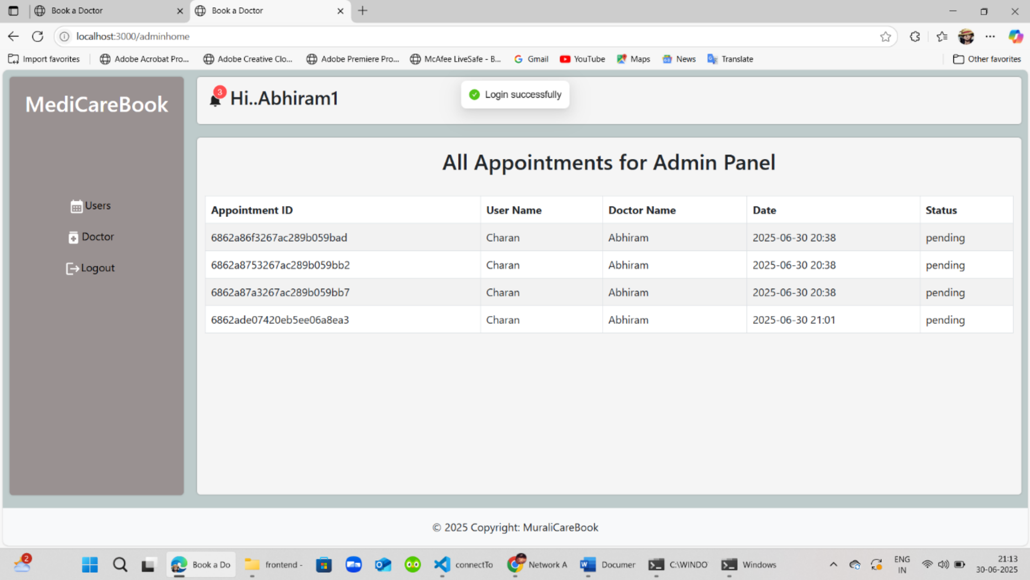

**Captoi n 3: Appointment Booking Modal**

**Captoi n 4: Admin Dashboard - Doctor Approval List**

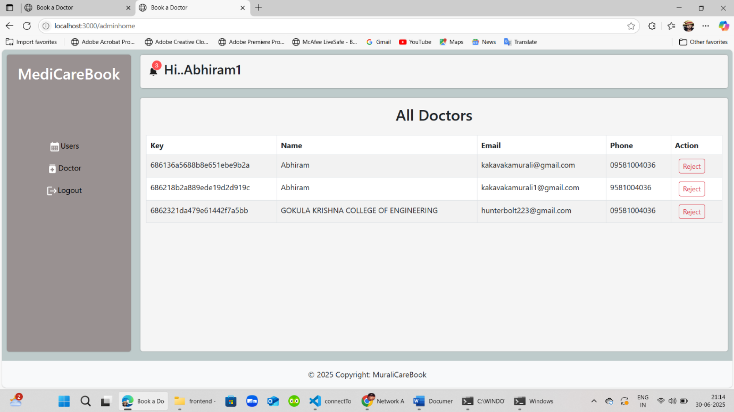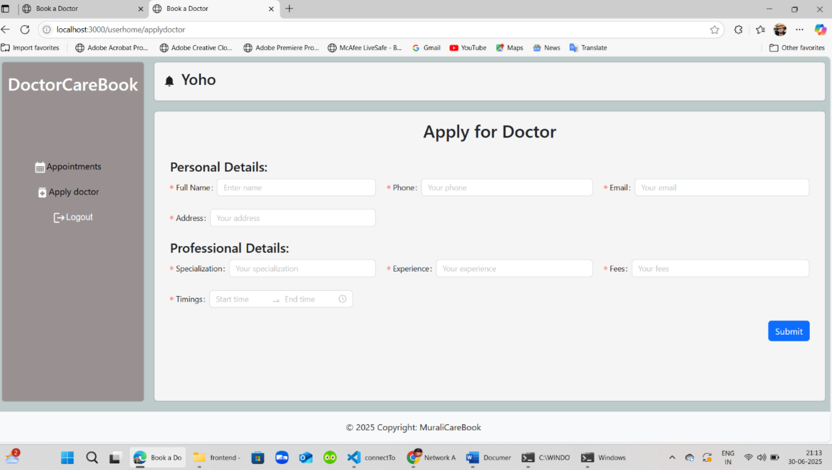

**Captoi n 5: Doctor's Dashboard - Upcoming Appointments**

**8. ADVANTAGES & DISADVANTAGES**

**Advantages**

|  |  |
| --- | --- |
| • | **Convenience:** Users can book appointments 24/7 without being restricted to office |

hours.

|  |  |
| --- | --- |
| •  • | **Efficiency:** Automates the booking process, reducing manual work for clinic staff  **Transparency:** Patients have clear visibility into doctors' schedules and credentials. |



|  |  |
| --- | --- |
| • | **Scalability:** The MERN stack architecture allows for easy scaling as the user base |

grows.

|  |  |
| --- | --- |
| • | **Centralized Management:** Provides a single platform for patients and doctors to |

manage all appointment-related activities.

**Disadvantages**

|  |  |
| --- | --- |
| • | **Internet Dependency:** The platform is entirely dependent on users having a stable |

internet connection.

|  |  |
| --- | --- |
| • | **Adoption Hurdle:** Requires both patients and doctors to adopt and actvi ely use the |

new system.

|  |  |
| --- | --- |
| • | **Data Security Responsibility:** Handling sensitive health information requires strict |

adherence to privacy regulations (like HIPAA), which adds complexity.

|  |  |
| --- | --- |
| • | **Lack of Telehealth:** The current version does not include integrated video |

consultations.

**9. CONCLUSION**

The DocSpot project successfully achieved its objective of creating a modern, functional, and

user-friendly platform for booking medical appointments. By leveraging the MERN stack, the

application provides a robust and scalable solution to a common real-world problem. The

project demonstrates a strong understanding of full-stack development principles, including

client-server architecture, RESTful API design, database management, and user

authentication. The finial product is a testament to the power of modern web technologies in

improving and streamlining traditional processes.

**10. FUTURE SCOPE**

The current platform serves as a strong foundation that can be expanded with several high-

value features:

|  |  |
| --- | --- |
| • | **Telehealth Integration:** Integrate a secure video conferencing API to allow for virtual |

consultations.

|  |  |
| --- | --- |
| • | **Online Payments:** Integrate a payment gateway like Stripe to handle consultation |

fees and co-pays.

|  |  |
| --- | --- |
| • | **Prescription Management:** Allow doctors to generate and send e-prescriptions to |

pharmacies.

|  |  |
| --- | --- |
| • | **Family Accounts:** Enable a user to manage appointments for dependents like |

children or elderly parents.



|  |  |
| --- | --- |
| • | **Dedicated Mobile Application:** Develop native iOS and Android applications for an |

enhanced mobile experience.

|  |  |
| --- | --- |
| • | **Ratni gs and Reviews:** Implement a system for verified patients to leave reviews for |

doctors.

**11. APPENDIX**

**Source Code**

The complete source code for the project is available at the GitHub repository linked below.

**Dataset Link**

This application does not use a static, predefine ed dataset. All data (user profiles,

appointments) is dynamically generated and stored in the MongoDB database through user

interaction with the live application.

**GitHub Link**

|  |  |
| --- | --- |
| • | **GitHub Repository:** <https://github.com/YonoStorm/DocSpot.git> |